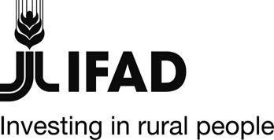
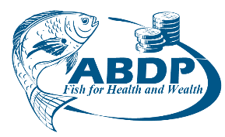

MINISTRY OF MINING, BLUE ECONOMY, & MARITIME AFFAIRS
STATE DEPARTMENT FOR FISHERIES, AQUACULTURE AND THE BLUE ECONOMY
AQUACULTURE BUSINESS DEVELOPMENT PROGRAMME

General Procurement Notice

Government of: Kenya
Project/procuring entity: Aquaculture Business Development Programme
GPN version: 4.1
GPN publication date: 6th March 2024

The National Treasury Kenya has received financing from the International Fund for Agricultural Development (IFAD) towards the cost of Aquaculture Business Development Programme and intends to apply part of the financing to payments for contracts for goods, works and services.

The procurement program for the financial year July 2023 – June 2024 period will include the following:

Procurements for FY 2023 - 2024

Procurement of goods to include:
- Procurement of fish feeds for farmers in nine programme counties
- Procurement of fish market equipment for 8 fish markets
- Supply and delivery of branded items for all component activities.
- Procurement of fingerlings for level one farmers (6905 farmers) in nine counties
- Enhancement of quality seed production and distribution Purchase of fish breeding equipment
Procurement of works to include:
- Supply and installation of solar power back-up for fresh fish markets
Procurement of consulting services to include:
- Consultancy for design and construction's supervision of landing sites

Contracts for goods, works and services will be implemented according to the principles, rules and procedures set out in the current versions of the IFAD Project Procurement Guidelines and IFAD Procurement Handbook and/or the Public Procurement and Asset Disposal Act 2015.
Specific procurement notices for contracts to be tendered under the competitive bidding procedures will be announced as they become available on selected portals, in local newspapers, and other media outlets as appropriate.
Interested eligible bidders and consultants who wish to be included on the mailing list to receive a copy of advertisements, or those requiring additional information, should send an email to the procurement department through email procurement@abdpcu.org using the subject line “GPN Version 4.1 for Aquaculture Business Development programme and indicating which of the procurement items they are interested in.

