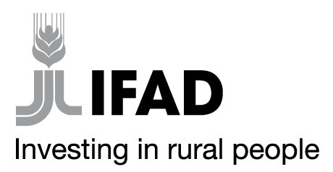
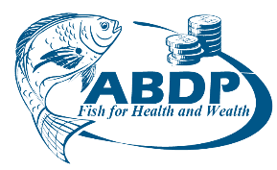

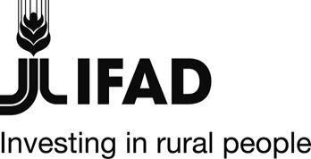
MINISTRY OF AGRICULTURE, LIVESTOCK, FISHERIES AND COOPERATIVES
STATE DEPARTMENT FOR FISHERIES, AQUACULTURE AND THE BLUE ECONOMY
AQUACULTURE BUSINESS DEVELOPMENT PROGRAMME(ABDP)
IFAD Loan No. 2000002052

Specific Procurement Notice ( Re-advertisement)
Country | Kenya
Name of Project | Aquaculture Business Development Programme (ABDP)
Contract Title | Supply of and delivery of Laboratory Equipment
Financing Agreements | 2000002052
NCB Reference  No | MOALF/SDFA&BE/ABDP/NCB/2021-2022/009

Aquaculture Business Development Programme is a partnership between the Government of Kenya, and the International Fund for Agricultural Development (IFAD). The Programme is expected to be completed in April 2026. It is implemented by the Ministry of Agriculture, Livestock, Fisheries and Irrigation, State Department for Fisheries, Aquaculture and Blue Economy and supervised by IFAD. The overall goal of the programme is to increase the incomes, food security and nutritional status of the wider communities of poor rural households involved in aquaculture in the targeted Counties. The Programme intends to use proceeds of the loan to procure assorted laboratory Equipment for programme implementation.
- Aquaculture Business Development Programme now invites sealed Bids from eligible Bidders for Supply and Delivery of Laboratory Equipment:

# | ITEM DESCRIPTION
LOT 1 | General Laboratory Equipment and Consumables
LOT 2 | Portable Water Testing equipment

- Bidding will be conducted through National Competitive Bidding (NCB) procurement and is open to all eligible Bidders as defined in the Procurement guidelines.
- Interested eligible Bidders may inspect the bidding document at the ABDP office situated at IFAD Building along Kamakwa Road, Nyeri before the tender closing date within working hours from 8.30 am to 4.30 pm on Mondays to Fridays, except on public holidays
- The bidding document can be downloaded by interested Bidders FREE OF CHARGE from the Ministry’s website: www.kilimo.go.ke under “tender’’ links or
www. abdpcu.org

- Bids must be delivered to the address below:
The Programme Coordinator
Aquaculture Business Development Programme
P.O.Box 904-10100
Nyeri
Kamakwa Road, Nyeri
On or before: 15th July 2022, 11.00 am EAT
Tenders will be opened on 15th July 2022, 11.30 am EAT.

- The equipment shall be inspected by the Inspection and Acceptance Committee to ensure conformity to specifications.

The Government of Kenya reserves the right at any time to terminate procurement proceedings.

PROGRAMME COORDINATOR

AQUACULTURE BUSINESS DEVELOPMENT PROGRAMME

