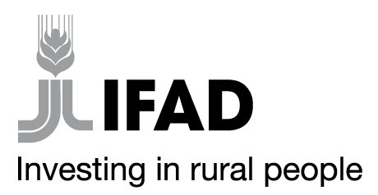
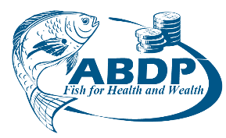

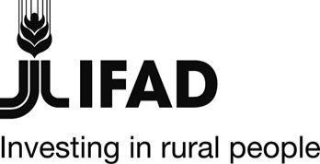
MINISTRY OF AGRICULTURE, LIVESTOCK, FISHERIES AND COOPERATIVES
STATE DEPARTMENT FOR FISHERIES, AQUACULTURE AND THE BLUE ECONOMY
AQUACULTURE BUSINESS DEVELOPMENT PROGRAMME(ABDP)
IFAD Loan No. 2000002052

Expression of interest ( Re-advertisement)
Country | Kenya
Name of Project | Aquaculture Business Development Programme (ABDP)
Contract Title | Independent Aquaculture Aggregators
Financing Agreements | 2000002052
Prequalification Reference | MOALF/SDFA&BE/ABDP/EOI/2021-2022/00 – 02
Aquaculture Business Development Programme is a partnership between the Government of Kenya, and the International Fund for Agricultural Development (IFAD). The Programme is expected to be completed in April 2026. It is implemented by the Ministry of Agriculture, Livestock, Fisheries and Irrigation, State Department for Fisheries, Aquaculture and Blue Economy and supervised by IFAD. The overall goal of the programme is to increase the incomes, food security and nutritional status of the wider communities of poor rural households involved in aquaculture in the targeted Counties.

The Programme intends to use proceeds of the loan to Support Farmers through Independent Aquaculture Aggregators in programme implementation and therefore invites Expression of Interest from eligible Independent Aquaculture Aggregators.

Two Independent Aquaculture Aggregators from each the Fifteen Counties which are implementing ABDP will be contracted. These counties are: Migori, Kakamega, Homa Bay, Nyeri, Meru, Kirinyaga, Tharaka Nithi, Kisii, Kisumu, Siaya, Busia, Embu, Kiambu, Machakos and Kajiado.

The scope of services to be offered by the IAAs will be governed by two contracts to be signed one with the Programme and another with smallholder farmers to be supported. The first contract is expected to provide guidelines on the use of a grant to support the IAA capacity development as well as a network of smallholder producers based on a well-defined business plan signed between the Programme and the IAA. The second will be a fish produce and input purchase/ sale agreement between the IAA and fish producers that will ensure a market for the small aquaculture producers at competitive prices and the provision of technical support and quality inputs. Typically, the IAAs will contribute in achieving the programme objectives by sustainably running their businesses and providing services to the network of smallholder farmers. The IAAs will be expected to outline the services to be offered to the smallholder farmers in their business plans to be submitted to the programme. Moreover, the contracts to be signed by a successful IAA will outline the responsibilities of the IAA under the programme

- Expression of interest will be conducted through Quality Based Selection (QBS) procurement and is open to all eligible Bidders as defined in the IFAD Procurement guidelines.
- Kindly note that this is a re-advertisement where scoring criteria has been revised. Those who had applied previously and were not successful may re-apply.

Qualification and Evaluation Criteria

Preliminary requirements

- Business Registration or Registration as a Co-operative
- Possess valid Business Permit
- Have a Valid Tax clearance certificate from Kenya Revenue Authority
- Evidence of business presence in the county of interest (letter from County Fisheries office confirming the presence)
- Bank statement for the last three months to demonstrate the operations and capacity of the business

Evaluation Criteria

Item | Criteria | Points
A. | General experience
i | Number of years in operation both general or specific experience | 5
ii | Be operating inclusive business model supporting a network of smallholder farmers and with capability to expand within 3 years. (include a list of some of the farmers supported including their telephone contact) | 25
B. | Specific experience
i | Be an aquaculture / fisheries value chain actor such as Cooperative society, Agro dealer , hatchery, fish feed suppliers etc with or potential to develop an aquaculture enterprise arm, hatchery operator, large producer, cottage fish feed industry, market intermediary operating on the input, output markets or both or offering other related supportive services such as technical assistance, pond construction and rehabilitation.( attach business profile) | 50
C | Available assets for supporting the Aggregation, that include Motorcycles, Vehicles, Freezers | 5
 | Demonstrate financial capacity (Bank accounts, assets or letter of credit)  • Score 2 Points for each Kes 1 million to maximum of 10 points  • Below Kes 1 Million is 2 Points | 10
 | Women , Youth or PLWD owned enterprise | 5
 | Total 5 | 100
 | Minimum points required to pass | 70

- The full EOI document can be downloaded by interested Bidders FREE OF CHARGE from the Ministry’s website: www.kilimo.go.ke under “tender’’ links or Programme website: www.abdpcu.org,
- Bids must be addressed and delivered to the address below:
Independent Aquaculture Aggregators
MOALF/SDFA&BE/ABDP/EOI/2021-2022/00–02

Aquaculture Business Development Programme;
Kamakwa Road opposite Golf Club Nyeri
P.O.Box 904-10100 Nyeri, Kenya
Tel: +254(0)721490056/750484817/754929293
E-mail: Procurement@abdpcu.org

On or before: 26th August 2022, 11.00 am EAT
Tenders will be opened on 26th August 2022, 11.30 am EAT.

The Programme reserves the right at any time to terminate procurement proceedings.

Regards

Programme Coordinator

Aquaculture Business Development Programme

