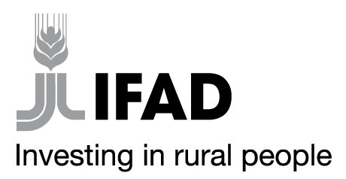
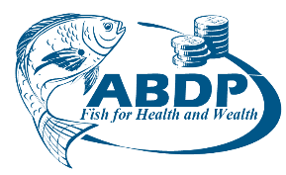

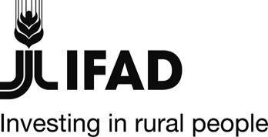
MINISTRY OF AGRICULTURE, LIVESTOCK, FISHERIES AND COOPERATIVES
STATE DEPARTMENT FOR FISHERIES, AQUACULTURE AND THE BLUE ECONOMY
AQUACULTURE BUSINESS DEVELOPMENT PROGRAMME(ABDP)
IFAD Loan No. 2000002052

SPECIFIC PROCUREMENT NOTICE

REQUEST FOR EXPRESSION OF INTEREST
Country | Kenya
Name of Project | Aquaculture Business Development Programme (ABDP)
Contract Title | Transaction Advisory and Technical Assistance for Programme Grants Management Consultancy
Financing Agreements | 2000002052
Prequalification Reference | MOALF/SDFA&BE/ABDP/EOI/2021-2022/12-01
Aquaculture Business Development Programme is a partnership between the Government of Kenya, and the International Fund for Agricultural Development (IFAD). The Programme is expected to be completed in April 2026. It is implemented by the Ministry of Agriculture, Livestock, Fisheries and Irrigation, State Department for Fisheries, Aquaculture and Blue Economy and supervised by IFAD. The overall goal of the programme is to increase the incomes, food security and nutritional status of the wider communities of poor rural households involved in aquaculture in the targeted Counties.
The Programme intends to use proceeds of the loan to procure consultancy to offer transaction advisory support and technical assistance for programme implementation and therefore invites Expression of Interest from eligible consultants.

The overall objective of this assignment is to provide transaction advisory support and technical assistance in the management of the various grants to be awarded by the Programme. Specifically, the consultant will support the Programme in the design of the grants, offer secretariat services in the whole process of grant start to exit and provide capacity building and monitoring evaluation for the Programme grantees

- Expression of interest will be conducted through Quality Cost Based Selection (QCBS) procurement and is open to all eligible Bidders as defined in the IFAD Procurement guidelines.

Qualification and Evaluation Criteria

Preliminary and Mandatory requirements

- Registration certificate from registrar of companies
- Valid Tax Clearance certificate

Evaluation Criteria

- General experience: Firm has been in existence for 10 years
- Demonstrated track record of managing and structuring similar output-based assignments in similar markets
- Experience with donor funded projects; attach evidence

- The Full Request for Expression of Interest document can be downloaded by interested Bidders FREE OF CHARGE from the UNDB website: https://devbusiness.un.org or Programme website: www.abdpcu.org,

- Bids must be addressed and delivered as follows:

Grants management Consultancy
MOALF /SDFA&BE /ABDP/EOI /2021-2022 /12-01
Aquaculture Business Development Programme;
Kamakwa Road opposite Golf Club Nyeri
P.O.Box 904-10100 Nyeri, Kenya
Tel: +254(0)721490056/750484817/754929293
E-mail: Procurement@abdpcu.org

On or before: 29th July 2022 at 11.00 am EAT
Tenders will be opened on 29th July 2022, 11.30 am EAT.

The Programme reserves the right at any time to terminate procurement proceedings.

Regards

Programme Coordinator

Aquaculture Business Development Programme

