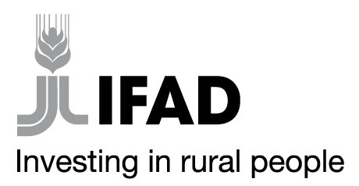

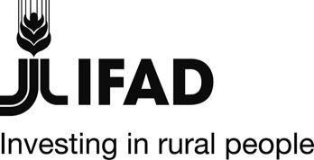
MINISTRY OF AGRICULTURE, LIVESTOCK, FISHERIES AND COOPERATIVES
STATE DEPARTMENT FOR FISHERIES, AQUACULTURE AND THE BLUE ECONOMY
AQUACULTURE BUSINESS DEVELOPMENT PROGRAMME(ABDP)
IFAD Loan No. 2000002052

Specific Procurement Notice
Country | Kenya
Name of Project | Aquaculture Business Development Programme (ABDP)
Contract Title | Provision of staff medical insurance cover
Financing Agreements | 2000002052
ICB Reference  No | MOALF/SDFA&BE/ABDP/NCB/2021-2022/14-01
Aquaculture Business Development Programme is a partnership between the Government of Kenya, and the International Fund for Agricultural Development (IFAD). The Programme is expected to be completed in April 2026. It is implemented by the Ministry of Agriculture, Livestock, Fisheries and Irrigation, State Department for Fisheries, Aquaculture and Blue Economy and supervised by IFAD. The overall goal of the programme is to increase the incomes, food security and nutritional status of the wider communities of poor rural households involved in aquaculture in the targeted Counties. The Programme intends to use proceeds of the loan to procure Staff medical Insurance.
- Aquaculture Business Development Programme now invites sealed Bids from eligible Bidders for PROVISION OF STAFF MEDICAL INSURANCE COVER as follows:

# | ITEM DESCRIPTION | Vendor Category
1 | Provision of staff medical insurance cover | Open to all qualified insurance companies

- Bidding will be conducted through National Competitive Bidding (NCB) procurement and is open to all eligible Bidders as defined in the Public Procurement Act 2015 and applicable IFAD guidelines.
- The bidding document can be downloaded by interested Bidders FREE OF CHARGE from the Ministry’s website: www.kilimo.go.ke; www.tenders.go.ke Programme website: www.abdpcu.org,

- Bids must be delivered to the address below:
The Programme Coordinator
Aquaculture Business Development Programme
P.O.Box 904-10100
Nyeri
Kamakwa Road, Nyeri
On or before: 4th January 2022, 11.00 am EAT
Tenders will be opened on 4th January,2022 11.30 am EAT.

The Government of Kenya reserves the right at any time to terminate procurement proceedings.

Regards

PRINCIPAL SECRETARY

State Department for Fisheries,
Aquaculture and the Blue Economy

